Hard Disk Virtualization (VHD) for Operating System, and Firmware Imaging and Reading Using Hyper-V

# **Requirements**

1. Hyper – V availability depends on the device’s Processor.
2. Ensure that your processor supports Virtualization features in the BIOS and is enabled.
3. Ensure that your device has sufficient hardware resources for the virtualized environment.
4. Ensure the old hard disk or drive is mounted.

# **Imaging HDD to VHD**

Procedure

1. Enable Hyper – V feature:
   1. Press the Windows button and search for “Turn on Windows features on and off”.
   2. Scroll and find “Hyper - V.’
   3. Ensure that “Hyper – V” is enabled (blue ticked). A screenshot of a computer

      Description automatically generated with medium confidence
   4. Restart the system as prompt.
2. Press the Windows button, search and open “Hyper – V Manager”. A screenshot of a computer

   Description automatically generated
3. Once opened, click on “Connect to Server” button on the right panel under “**Actions**” 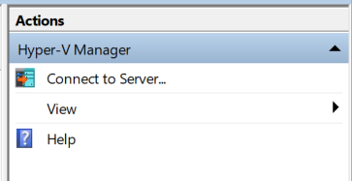
4. Select “Local computer”
5. A screenshot of a computer

   Description automatically generatedUnder the “Actions” panel, click on “New” and select “Hard Disk”.
6. Click “Next” on the “Before You Begin” tab.
7. Select VHDX on the “Choose Disk Format” tab and click “Next”.
8. Select “Dynamically Expanding” on the “Choose Disk Type” tab and click “Next”.
9. Enter a new virtualized hard disk name and ensure that it ends with “. vhdx”.
10. Click “Browse…”, select the location to store the new VHD, and click “Next”
11. Select “Copy the contents of the specified physical disk”.
12. Select the old physical disk or disk drive to perform the imaging and click “Next”.
13. Click “Finish”.
14. Imaging process will begin and takes time depending on the size of the disk.

# **Use VHDX as Virtual Machine**

Procedure

1. On the right panel, under “Actions”, click “New”, and click “Virtual Machine”.

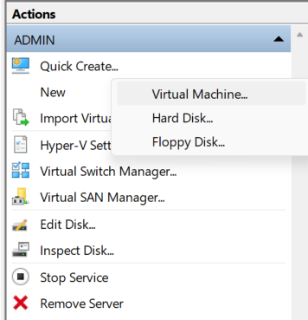

1. Click “Next” on the Before You Begin page.
2. Type in a new virtual machine name and click “Next”.
3. Select “Generation 2” on the Specify Generation page and click “Next”.
4. Ensure that “Use Dynamic Memory for this virtual machine” is ticked and click “Next”.
5. For the Connection drop down menu, select “Default Switch” and click “Next”.
6. Select “Use an existing virtual hard disk”.
7. Click “Browse”, select the imaged VHDX and click “Next”.
8. Click “Finish”
9. Hyper – V will start importing the virtual machine.
10. At the dashboard, navigate to the right and bottom section that labels the virtual machine and click “Start”.

1. Once started, click “Connect” to connect and use the virtual machine.